Hall Mangement System

Group : 06

Submitted to:  
**Sajjadur Rahman**  
Lecturer, Dept. of CSE

**Johra Muhammad Moosa**Lecturer, Dept. of CSE

Submitted by:

Shishir Kumar Sarkar (1005040)  
Yahya Ahmed Sharif (1005048)  
Ehsan-Ul-Haque (1005052)  
Mahmood Ahmed (1005055)  
Nayeem Islam (1005060)

Introduction:  
 Our present hall management system is way too backdated. This is not suitable for both the students and the hall management authority. To keep up with this current digital world we need an upgraded well design information system.

Subsystems:

1. Computerized Hall Seat Allocation

2. Hall Mess management System

3. Virtual Notice Board & Complain box

4. Room Maintenance System

5. Event Management System

There are four type of user

* Students
* Provosts
* Staff members
* Mess Managers

Our report is on the Graphical User Interface (GUI) design for our system. We have designed the GUI for the separate users.

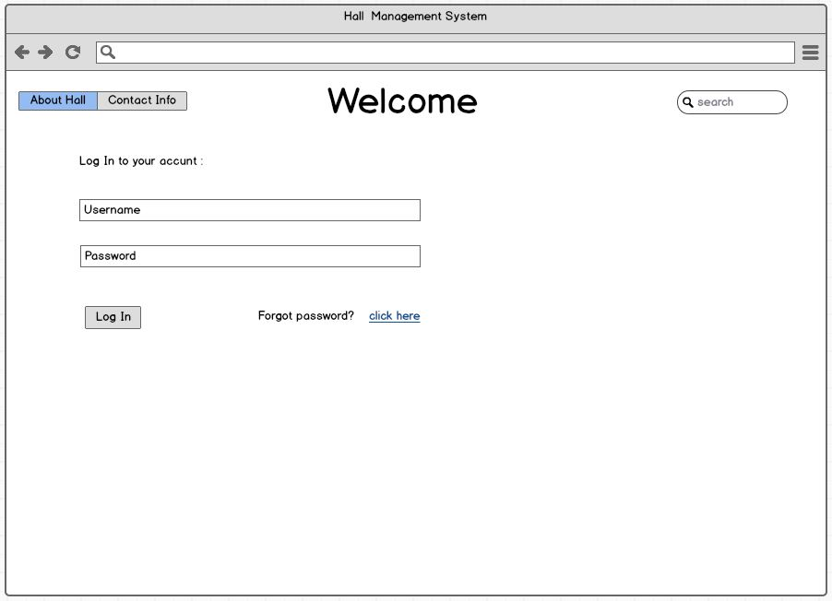

Fig 1 welcome page for students

This page is for log in for the users. The user can log his to his account by his username and password.

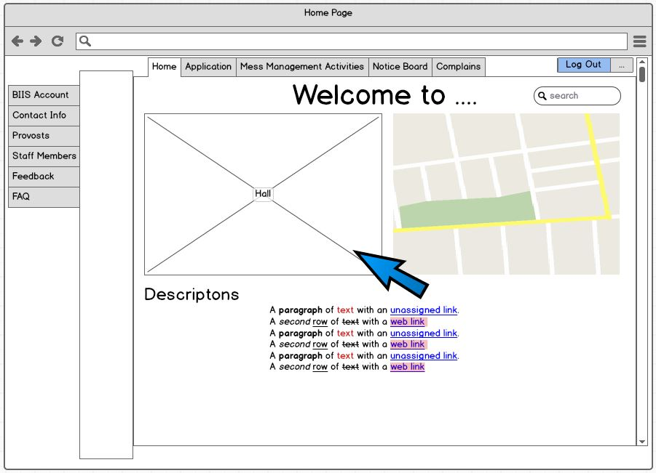

Fig 2 Home page for students

This is the homepage for the student users. Here a brief description of the hall is given along with a picture from google map.

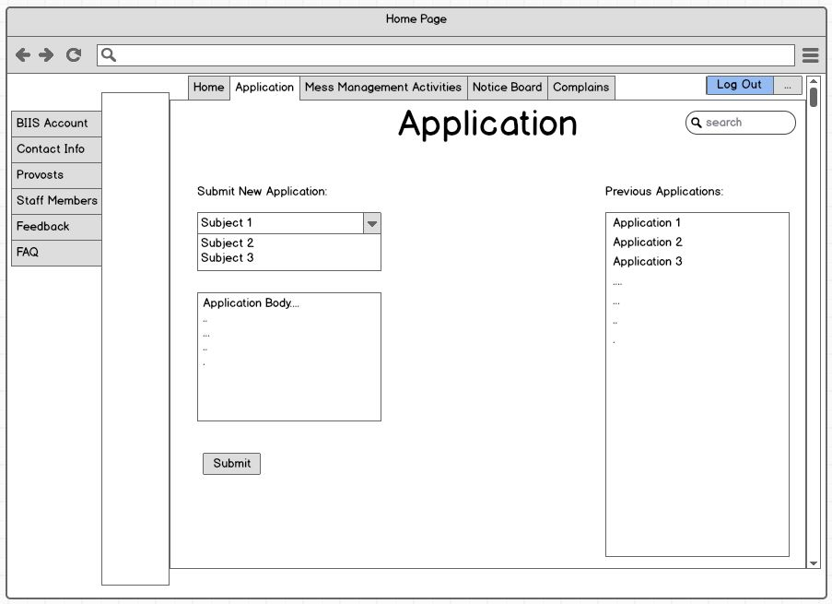

Fig 3 Application page for students

This is the application page for the students. Here is a list of previous applications and a list of new applications. After filling up the application form students can submit the form by clicking the submit button.

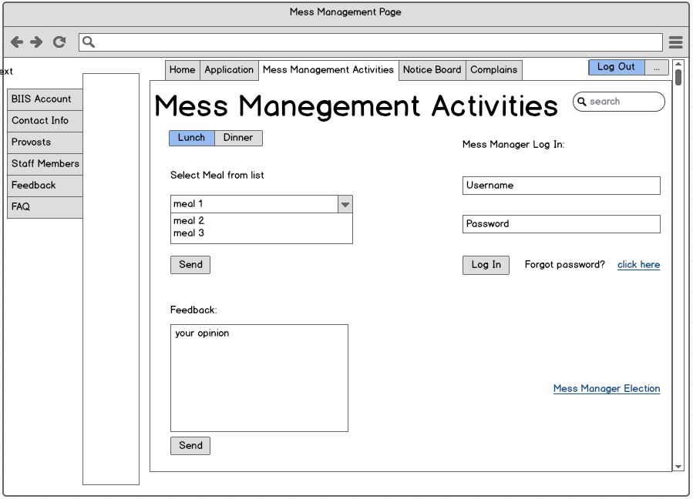

Fig 4 Mess Management activities page for students

This page is for student’s mess management activity. Here we can see there are two choices lunch and dinner. After clicking any of these students select menu and send it by clicking the send button. Here is a feedback box where students can give feedback and submit.

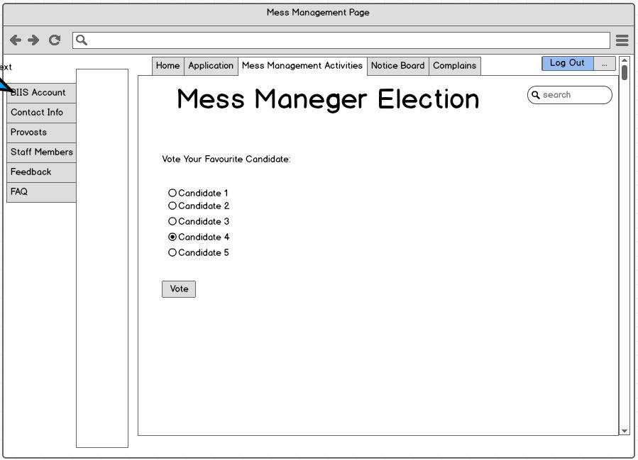

Fig 5 Mess Manager Election page for students

This is mess manager election page. Students can vote candidates and submit vote by clicking the vote button.

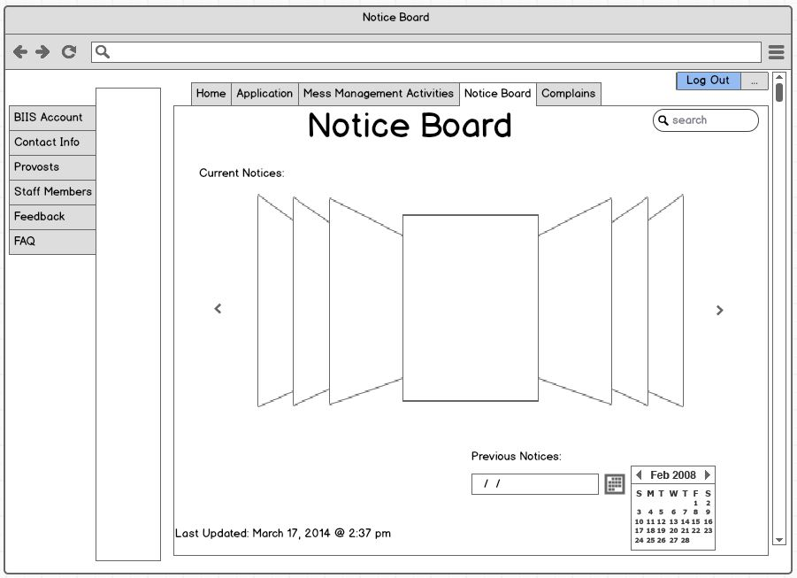

Fig 6 Notice Board page for students

This page is for notice board. Students can find the notice of their desired dates by using the calendar given below.

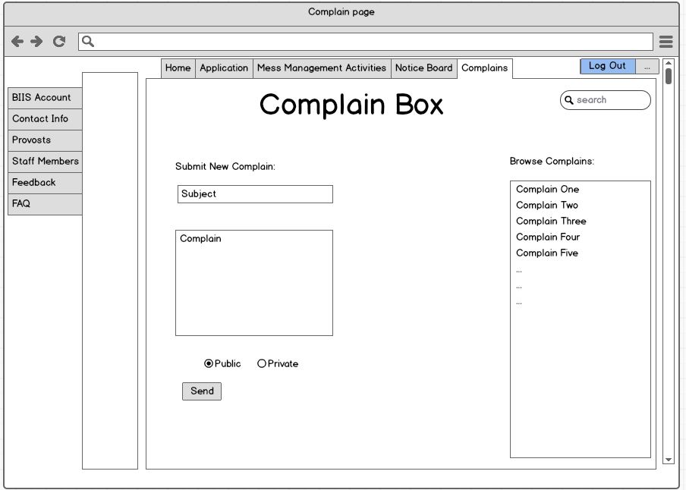

Fig 7 Complain box page for students

This page is for complain box. There is a box for writing complains. After writing the complain students can send them by clicking the send button. There are two extra buttons named as ‘public’ and ‘private’. By clicking one of these buttons students can make their complains visible to all or invisible.

Provost



Fig 8 welcome page for provost

This is the welcome page for the provost. He can log in to his account by his user name and password.

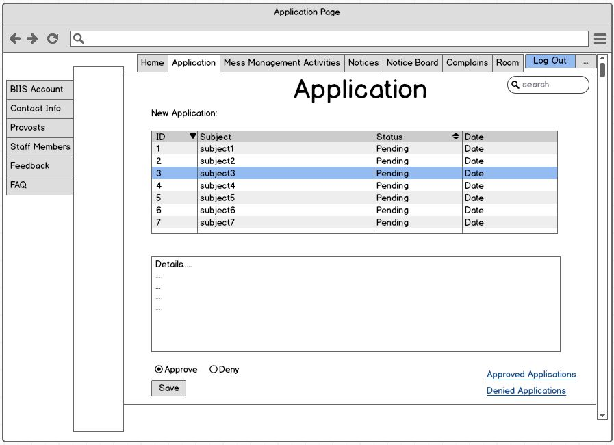

Fig 9 Application page for provost

This is the application page for the provost. Provost can find the applications and applications details by clicking the application id. Application details can be found in the box below. After processing the applications he can approve or deny. There are two buttons below for this. After this he saves it.

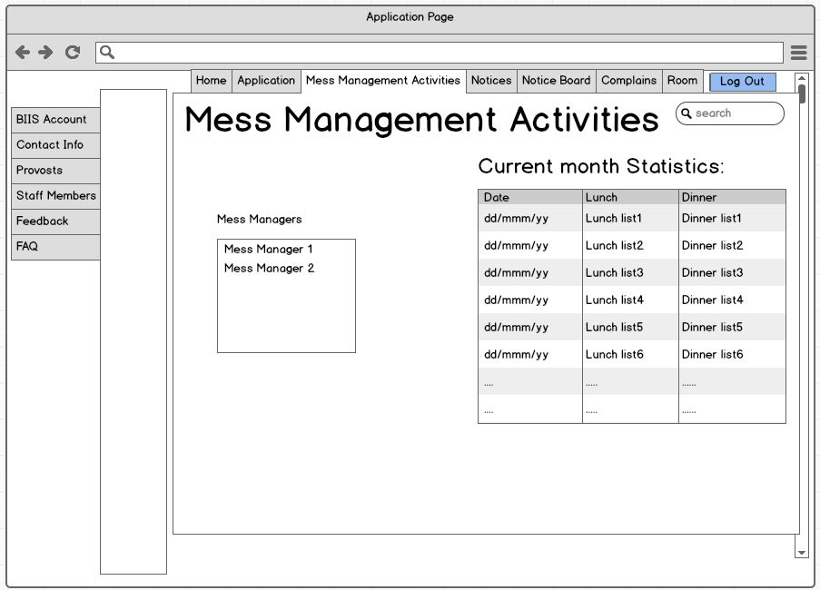

Fig 10 Mess Management Activities page for provost

This page is for mess management activities. Provost can find the month statistics here.

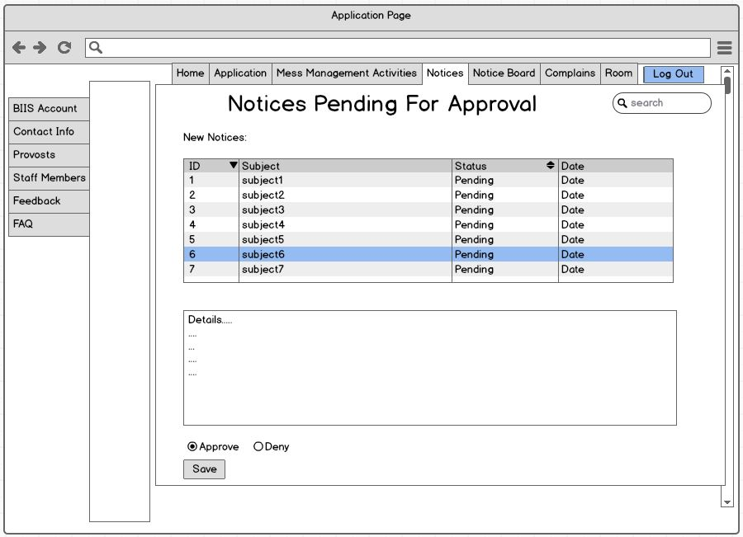

Fig 11 notice pending for approval page

In this page provost sees the pending notice. Then he approved notices for publication by clicking the approve button.



Fig 12 notice board page for provost

Provost can see the published notices in different dates.

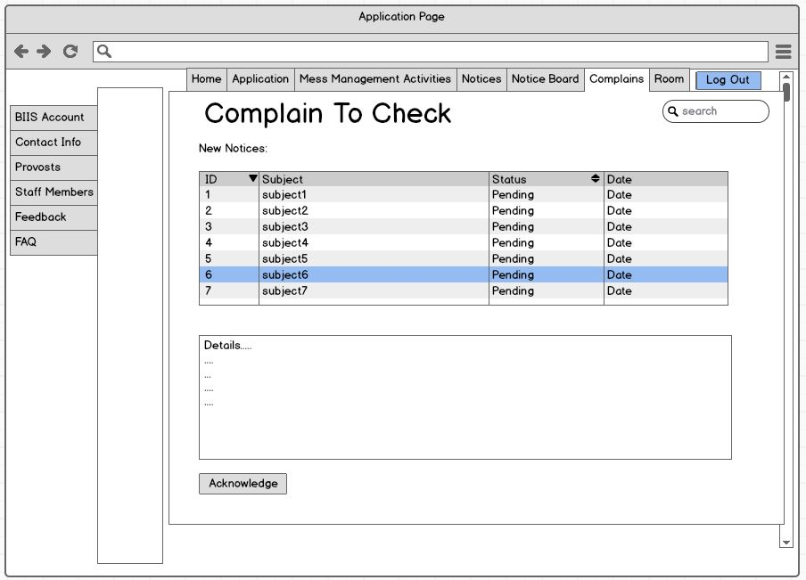

Fig 13 complain box page for provost

Provost can see a list of complain. He can also find the complain details. Provost acknowledge a complain by clicking this button.

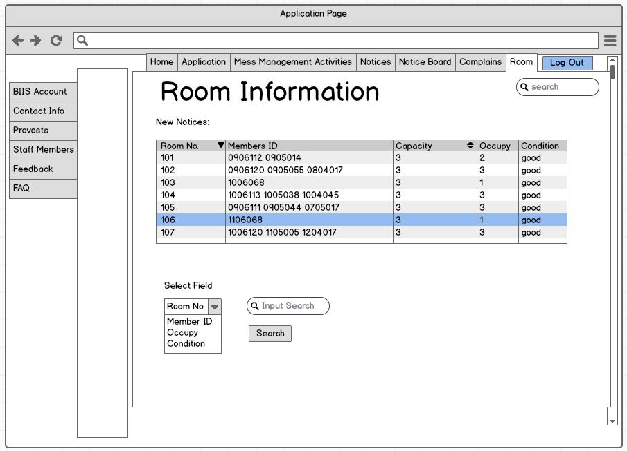

Fig 14 room information page for provost

There is a table here. From this table we can find the room numbers and the students in this room, room capacity and condition.

Staff Member

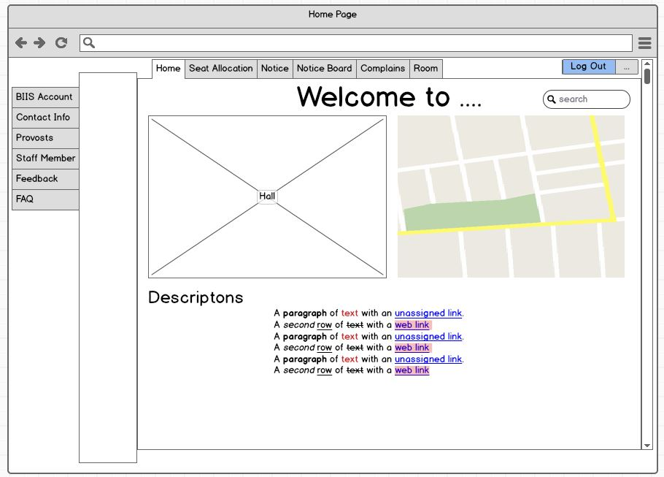

Fig 15 home page for staff member



Fig 16 seat allocation page for staff member

This is the seat allocation page for the staff member. There is a table that contains student name, student id. Staff member can find whether a student is allowed for seat or not. There is a table that contains empty room and available seats in these rooms. Then the staff member allocate student in a certain room and save this.

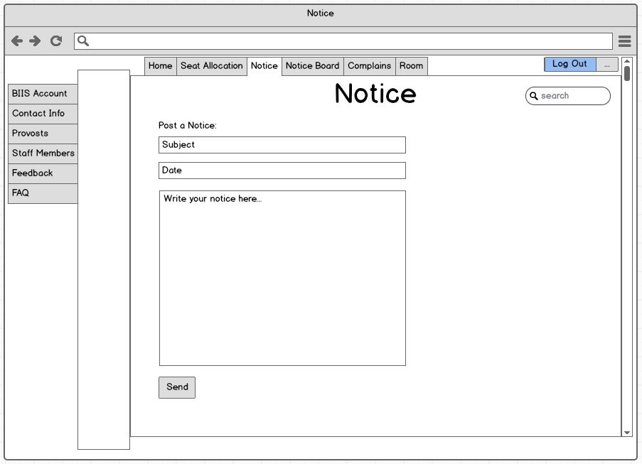

Fig 17 notice page for staff member

This is the notice page for the supervisor. Supervisor prepares notice by using this page. Here is a box named subject and another box where a notice detail is written. Then the notice is sent using the send button.

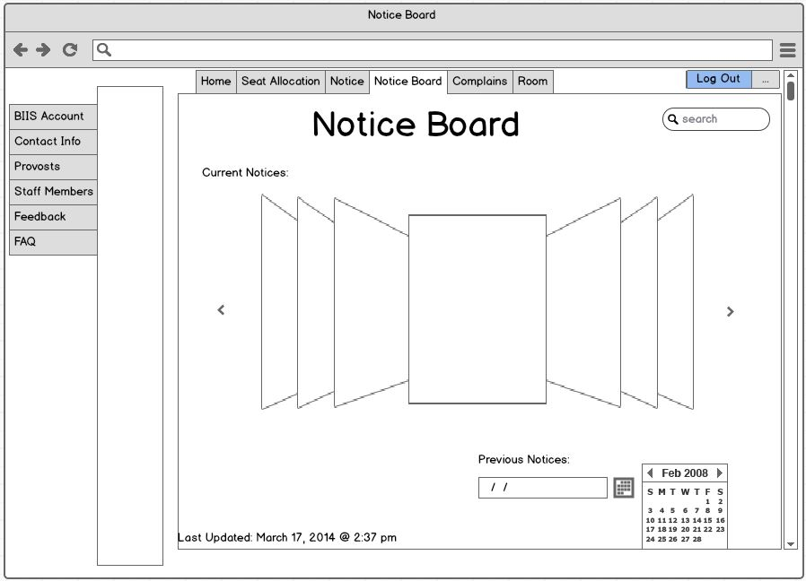

Fig 18 notice board page for staff member

This is the notice board page for the supervisor. Here supervisor can see the notices that have been published before.

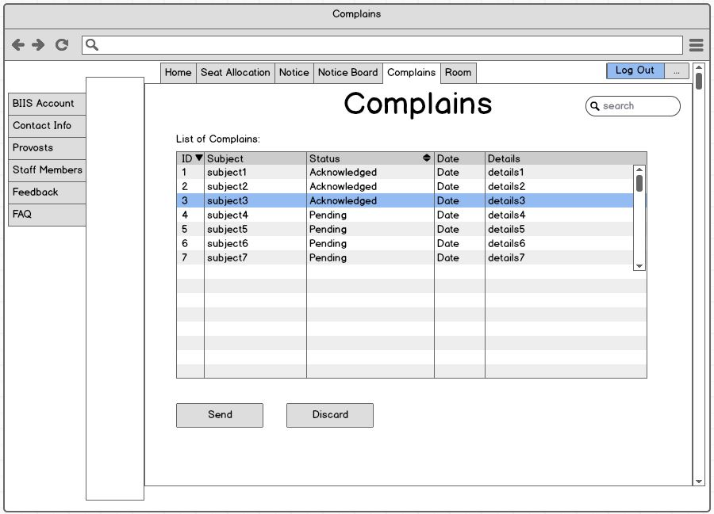

Fig 19 complains page for supervisor

This is the complain page for the supervisor. Here supervisor can see complains submitted by the students. Then he acknowledges complains and send to the provost.

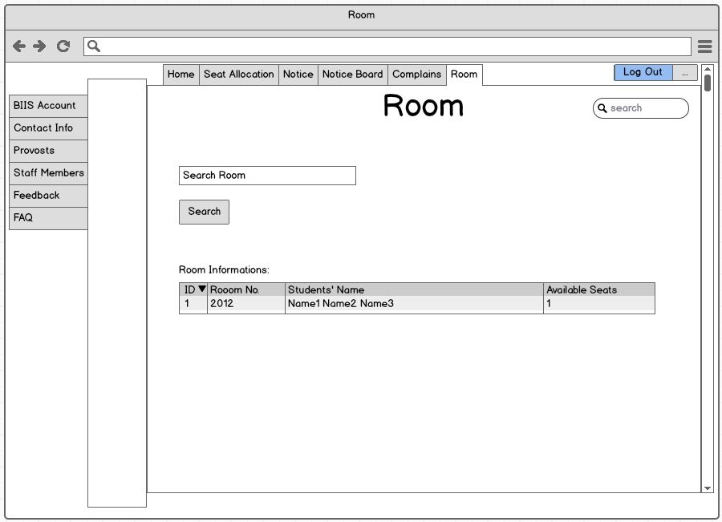

Fig 20 room page for staff member

This is the room page for staff member. Here he can search for rooms by giving the room no then finds the students in the room, number of available seats etc.

Mess Manager



Fig 21 mess management activities for mess manager

This is the mess management activities page for mess manager. He can select meal from here. He can also give his feedback.

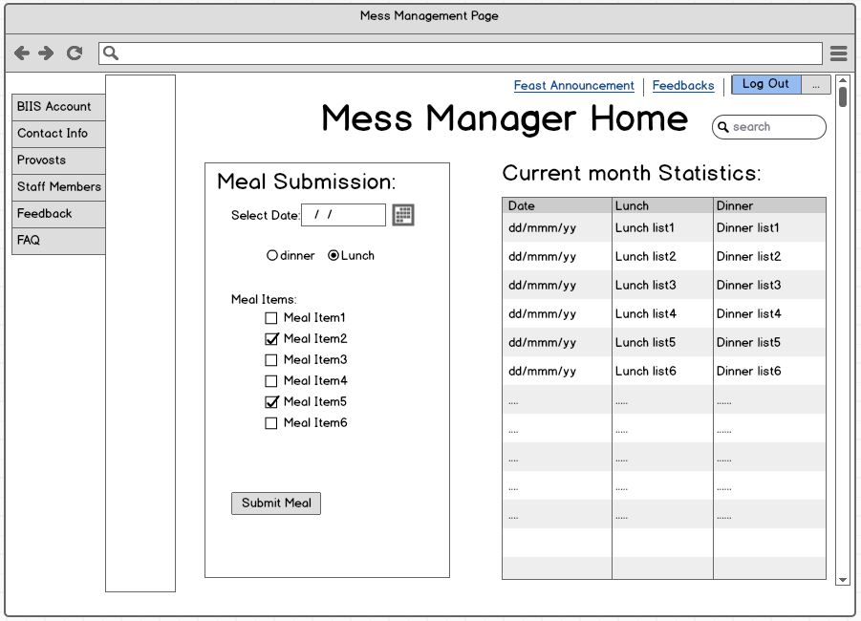

Fig 22 mess manager home page

This is mess manager home page. Mess manager can give menu list from this page. There is also a table that contains the current month statistics.

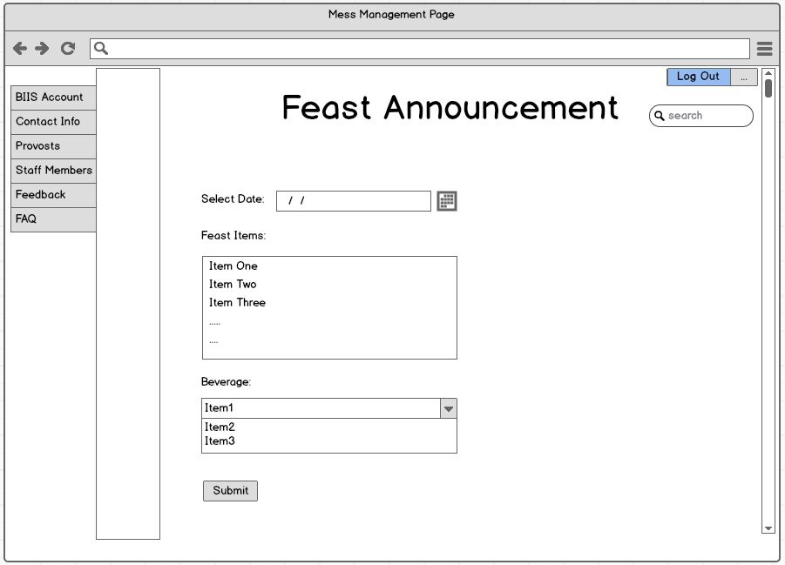

Fig 23 Feast Announcement page

This is the feast announcement page for mess manager. Here manager can select date in which hall feast will be given and also give the feast menu list.

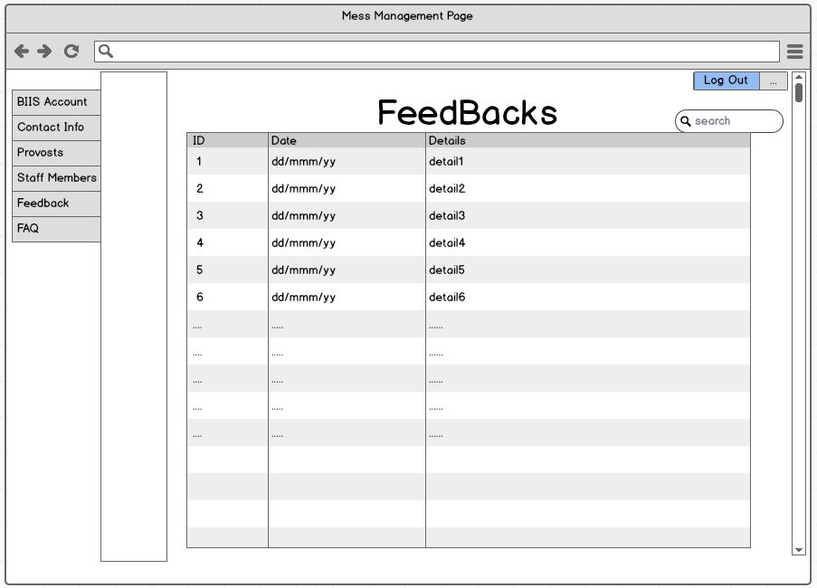

Fig 25 Feedbacks page for mess manager

This is feedback page for mess manager. Here he can see the feedback details in different dates given by the students.